TEAM4OIES

Software Project Management Plan
(SPMP)

LOC: 1000

Cost in dollars: $40,437

Effort in Person-Months: 8.1

Version 2.0

Signature Block

COSC 4351 | Name Signature | Date
SE Team Leader
SE SQA
SE SQA

Outline
Revision Chart
Preface
Contents
1. Introduction
1.1 Project Overview
1.2 Project Deliverables
1.3 Evolution of the Software Project Management Plan
1.4 Reference Materials
1.5 Definitions and Acronyms
2. Project Organization
2.1 Process Model
2.2 Organizational Structure
2.3 Organizational Boundaries and Interfaces
2.4 Project Responsibilities
3. Managerial Process
3.1 Management Objectives and Priorities
3.2 Assumptions, Dependencies, and Constraints
3.3 Risk Management
3.4 Monitoring and Controlling Mechanisms
3.5 Staffing Plan
4. Technical Process
4.1 Methods, Tools, and Techniques
4.2 Software Documentation
4.3 Project Support Functions
5. Work Packages, Schedule, and Budget
5.1 Work Packages
5.2 Dependencies
5.3 Resource Requirements
5.4 Budget and Resource Allocation
5.5 Schedule
6. Additional Components
7. Index
8. Appendices

Detailed Contents

Revision Chart
Version | Primary Author(s) | Description of Version | Date Completed
Draft | Steven Pate, Jainesh Mehta, Sarah Moore | Initial draft created for distribution and review comments | 3/30/2015
Preliminary | Steven Pate, Jainesh Mehta, Sarah Moore | Second draft incorporating initial review comments, distributed for final review | 3/31/21/2015
Final | Steven Pate, Jainesh Mehta, Sarah Moore | First complete draft, which is placed under change control | 4/1/2015
Revision 1 | TBD | Revised draft, revised according to the change control process and maintained under change control | TBD
Revision 2 | TBD | Revised draft, revised according to the change control process and maintained under change control | TBD
etc. | TBD | TBD | TBD

Preface
The Software Management Plan details the way that the team will approach the project. The document includes how the project is organized, the processes used, schedule, and budget.

Contents
- Introduction (page 4)
- Project Organization (page 5)
- Managerial Process (page 8)
- Technical Process (page 9)
- Work Packages, Schedule, and Budget (page 11)
- Additional Components (page 16)
- Index (page 16)
- Appendices (page 16)

List of Figures
Figure 5.1
COCOMO model (page 12)
Figure 5.2
MS project schedule (page 14)

1.0 Introduction

1.1 Project Overview
This project involves designing a website where surgeons can upload EVAR data. The website allows computational scientists to segment and extract anatomical features, CFD scientist to perform simulations to extract functional features, and auditors to audit the website’s database. The client will receive the website along with documentation such as the UML use case, MVC class diagram, and software requirements specifications.

The project will go through multiple phases between February 2015 and April 2015 which include inception, elaboration, construction, and transition. The project costs an estimated $40,437 and takes 8.1 person-months. The project uses the COCOMO suite of constructive cost models to estimate the cost.

1.2 Project Deliverables
- UML use case document (due 2/11/2015 via electronic and hard copy)
- UML MVC class diagram document (due 2/11/2015 via electronic and hard copy)
- Software Requirement Specifications (due 3/9/2015 via electronic and hard copy)
- Team project report (due 2/11/2015 via electronic and hard copy)
- ERD Model (due 3/9/2015 via electronic and hard copy)
- Data Requirements Specifications (due 3/9/2015 via electronic and hard copy)
- Software Project Management Plan (due 4/1/2015 via electronic and hard copy)
- Website with full functionality and acceptance testing (due 4/29/2015 acceptance testing delivered via electronic and hard copy)

1.3 Evolution of the Software Project Management Plan
The initial draft will be available for review on 3/29/2015. SQAs will review the document and recommend changes. The primary authors will clean up the document and make the necessary changes. This preliminary version will be submitted by 3/31/2015. A final review will occur, and the final changes will be recommended. The document will receive a final revision to prepare it for the turn in date.
Current Version: Preliminary 3/31/2015
Version | Primary Author(s) | Description of Version | Date Expected
Draft | Steven Pate, Jainesh Mehta, Sarah Moore | Initial draft created for distribution and review comments | 3/29/2015
Preliminary | Steven Pate, Jainesh Mehta, Sarah Moore | Second draft incorporating initial review comments, distributed for final review | 3/31/2015
Final | Steven Pate, Jainesh Mehta, Sarah Moore | First complete draft, which is placed under change control | 4/1/2015
Revision 1 | Steven Pate, Jainesh Mehta, Sarah Moore | Revised draft, revised according to the change control process and maintained under change control | TBD

1.4 Reference Materials
- COCOMO suite of constructive models
- MS Project
- Unified Process

1.5 Definitions and Acronyms
COCOMO- software cost estimation model
Unified Process- iterative and incremental software development process
ERD- entity relationship diagram

2.0 Project Organization

2.1 Process Model
- Our life cycle process is similar to that of the Agile Software Development, but with more documentation. Roughly once every two weeks ANONYMIZED TEAM4OIES meets to discuss in detail, what needs to be done and to organize and distribute work and information. Two days a week the team briefly meets for less than 10 minutes to quickly answer any questions or concerns.
- The project has four major milestones. The first is the Read Team Deliverables. This includes basic textual analysis. This milestone’s due date is February 11. The second is the Purple Team Deliverables. This includes any corrections that are needed, plus new requirements documents. This milestone’s due date is March 9. The third is the Blue Team Deliverables. This includes more requirements documents. This also includes completing the web site pages. This milestone’s due date is April 1. The last milestone is the completed software which is due April 29.
Work Product Name | Planned Completion Date | Placed Under Change Control? | Deliverable to Customer? | People Who Must Sign Off on the Work Product
Software Project Management Plan  This is the controlling document for managing a software project, and it defines the technical and managerial processes necessary to deliver the project requirements. | 04/01 | Yes | No | Team Leader, DBAs, TMs, and SQAs
Black Box Test Cases  This contains the test cases based on the requirements. | 04/01 | Yes | No | Team Leader, DBAs, TMs, and SQAs
Feasibility Study  This is the document for understanding how much the software project could cost and if it is possible to create. | 02/11 | Yes | No | Team Leader, TMs, and SQAs
Input Forms and Output Reports  This document shows any and all input forms and what the proper outputs from these forms would look like. | 02/11 | Yes | Yes | Team Leader, TMs, and SQAs
UML OOA MVC Class Diagram  This is the document that shows the analysis of the requirements and maps out the classes and their connections to each other. | 04/29 | Yes | No | Team Leader, TMs, and SQAs
UML OOA Use Case Diagram  This document shows the actors and the different methods in the controller that the actors have access to. | 04/29 | Yes | No | Team Leader, TMs, and SQAs
Software Requirements Specification  This is the requirements document which gives the exact specifications for what the software project needs and where it can be found. | 03/09 | Yes | Yes | Team Leader, TMs, and SQAs
Team Project Report  This document gives an outline to everything that is needed to understand the project, much like an instruction manual. | 04/29 | Yes | Yes | Team Leader, DBAs, TMs and SQAs
Web Site Design  This document simply lays out how the website it to look and where all of the elements are located. | 03/09 | Yes | No | Team Leader, TMs, and SQAs
Data Requirements Specification  Much like the Software Requirements Specification, this document pertains to the data stored in the database. | 03/09 | Yes | Yes | Team Leader, DBAs, and SQAs
ERD Modeling  This document displays entities and their relationships to each other. This pertains to the database side of the document. | 04/29 | Yes | No | Team Leader, DBAs, and SQAs

2.2 Organizational Structure
Team Leader
In charge of overall operations and division of labor

Software Quality Assurance members
In charge of maintaining quality of every part of the software and its documentation

Team Members
In charge of creating most of the front of the software

Database Administrators
In charge of creating and maintaining the database

2.3 Organizational Boundaries and Interfaces
- Team Leader: Javier Rivera communicates with the Course Instructor: Victoria Hilford
- Course Instructor: Victoria Hilford communicates with the Customer: Dr. Adeline Schwein

2.4 Project Responsibilities
Database Administrators are responsible for the database and the documents ERD and Data Requirements Specifications. Team Leader is responsible for setting due dates, allocating time for meetings, and making sure that the product is getting prepared on time. Software Quality Assurance members are responsible for making sure that everything that is completed is up to the quality that is required. The team members are responsible for almost everything else.

3.0 Managerial Process

3.1 Management Objectives and Priorities
The priority is to disperse work evenly between members to make sure the project gets completed in a timely fashion without placing too much work on one person. Using third party or new software will be undertaken by multiple members to better understand the software and allow that it is adapted properly. Frequent tests will be run to find and fix errors as well as guarantee the quality is up to the correct standard.

3.2 Assumptions, Dependencies, and Constraints
We assume that the customer will complete their analysis program to allow our program to be of real use. The main constraint is that the data will require a large amount of space that may not be available.

3.3 Risk Management
Risks will be identified through testing which will help us find any problems. Software Quality Assurance Members will also help by reviewing all sections of the project and searching for any missed problems or potential problems.

3.4 Monitoring and Controlling Mechanisms
ANONYMIZED TEAM4OIES will have sections of work that are due at specific times. Using a task board, work can be submitted for verification. Three days before a section is due, all members will gather to discuss the quality of the work. From that point on, only corrections and updates are made to the sections. Once the parts are verified, they are considered complete. Twice a week short meetings of no more than 10 minutes will be held to ask questions and discuss concerns. Constructive cost models will be created to determine price and feasibility of the project.

3.5 Staffing Plan
Nine members will be needed to conduct the project. The skill level will be from moderate to advanced for this project. The project will start late January and last for three months. Members volunteer for their roles and are confirmed as members by the Team Leader, who is also a volunteer. There is mild training which is administered periodically throughout the three months. The team is as follows:
Team Leader – Javier Rivera
Software Quality
Assurance Members – Linh Tong
Paul Miller
Database Administrators – Logan Stark
Jainesh Mehta
Team Members – Daniel Gonzalez
Sarah Moore
Steven Pate
Janaye Maggart

4.0 Technical Process

4.1 Methods, Tools, and Techniques

TEAM4OIES will be using Unified Process for software development. Some of the tools and software we will be using are:

-MS Visual Studio 2010: To create, develop, and debug TEAM4OIES software.

-TortoiseSVN: Version control tool.

-MS Word: For creating software documents and UML diagrams.

-MS Project: To create and track the project schedule.

-MS SQL Server: For backend database.

-COCOMO: To estimate resources and scheduling.

4.2 Software Documentation

TEAM4OIES will be responsible for providing extensive documentation of its software. Below are list of these documents and use of these documents will provide trouble less development and maintenance of TEAM4OIES software.

Software Project Management Plan: Contains list of documents for TEAM4OIES, Scheduling, plans, and TEAM4OIES goals.

Web Site Design: This document contains basic template for TEAM4OIES website and its functions.

UML OOA MVC CLASS DIAGRAM: Shows TEAM4OIES class view and how they are related.

UML USE CASE DIAGRAM: Shows Actors interaction with TEAM4OIES software.

ERD Modeling: This document contains entities and their relationship for TEAM4OIES database.

Data Requirements Specification: In this doc shows attribute’s access type and ERD model.

Relational Model: Shows 1NF, 2NF, and 3NF Table of TEAM4OIES database.

Black Box Testing: Shows acceptable case for TEAM4OIES data.

These documents and their contents are subject to change as client provides more feedback and new information is discovered.

4.3 Project Support Functions

UML OOA MVC CLASS DIAGRAM

UML USE CASE DIAGRAM

Web Site Design

ERD Modeling: Data Requirements Specification

Relational Model

Black Box Testing

5.0 Work Packages, Schedule, and Budget

5.1 Work Packages
Work Package

Green Iteration (3/30-4/12)
Task Duration
11 Days
UC3: AnonymizeBEFOREUploadEVARData

11 Days
UC1: Register

11 Days
UC5: UploadzipAnonymizedPatientLocaltoServerEVARData

11 Days
UC4: ZipAnonymizedPatientEVARData

11 Days
UC9: DataAnalysis
11 Days
UC8: VisualizeDatabaseEVARMetadata
11 Days
UC14: AddTestimonial
11 Days
UC10: Segmentation
11 Days
UC15: SearchTestimonials
Orange Iteration (4/12-4/26)
Task Duration

11 Days
UC6: UnzipUploadedPatientEVARData
11 Days
UC2: Login

11 Days
UC11: CFDSimulation
11 Days
UC7: StoreinDatabaseEVARMetadata

11 Days
UC13: DatabaseAudit
11 Days
UC12: DecisionProcess

11 Days
UC16: Chat

5.2 Dependencies

For TEAM4OIES Orange Iteration depends on Green Iteration to be successfully completed. TEAM4OIES end product depends on both Orange and Green Iteration to be successfully completed.

5.3 Resource Requirements
TEAM4OIES consists of nine members; every member of team will be required to write contributing code for the website. Resources required for this project are MS SQL server for DBAs, Computer with Visual studio 2010 for each team members, and 8.1 person-months from each team members. Below is list of TEAM4OIES members.

Role | Name | Contact
Team Leader | Javier Rivera | Jrivera AT uh dot edu
SQA | Paul Miller | Paulmiller347664 AT gmail DOT com
SQA | Linh Tong | Linhtong AT Hotmail DOT com
DBA | Jainesh Mehta | Jainesh AT gmail DOT com
DBA | Logan Stark | Logan.d.stark AT gmail DOT com
Team Member | Daniel Gonzalez | Uhdanielg AT gmail DOT com
Team Member | Janaye Maggart | Janayemaggart AT gmail DOT com
Team Member | Sarah Moor | Sarahninety AT gmail DOT com
Team Member | Steven Pate | Stevenapate AT Hotmail DOT com

5.4 Budget and Resource Allocation
Please refer to Fig. 5.1 for Budget and Resource calculations.

Figure 5.1
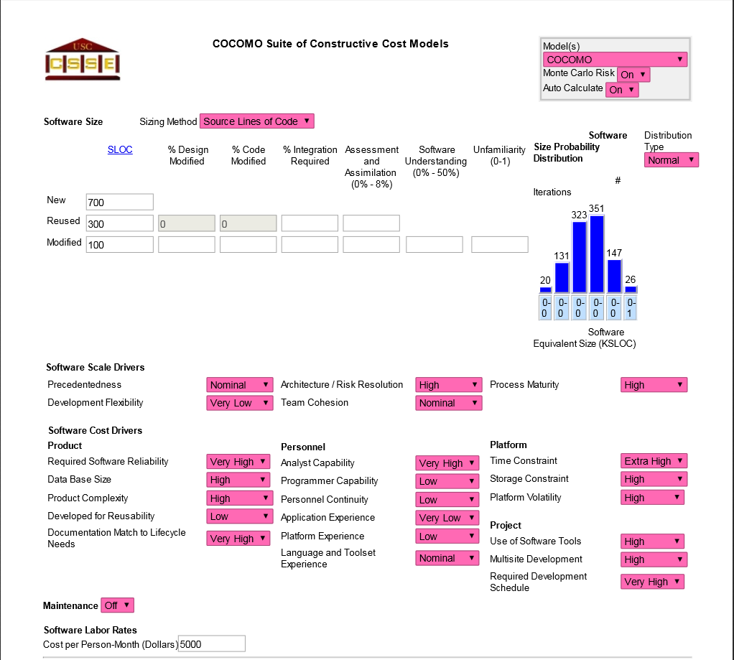
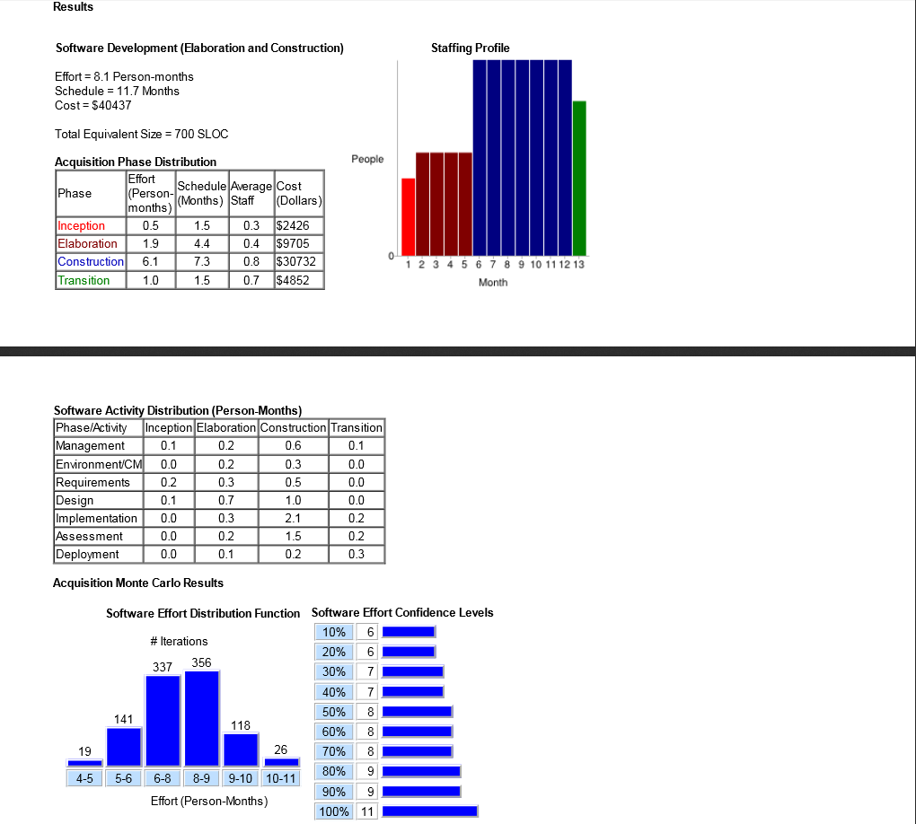

5.5 Schedule
Fig 5.2 below shows TEAM4OIES’s schedule.
Figure 5.2
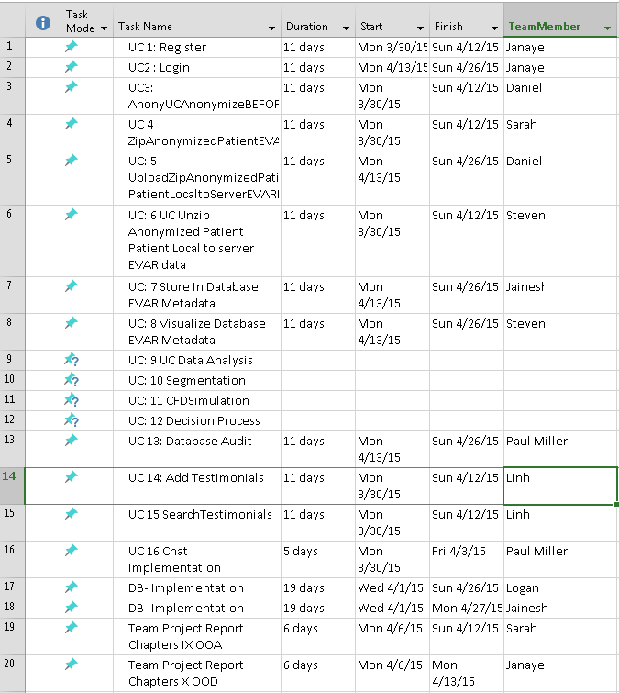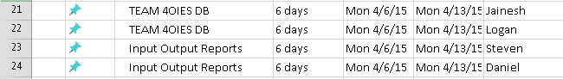

6.0 Additional Components
COCOMO used for calculating software cost in dollars and time.
http://csse.usc.edu/csse/research/COCOMOII/cocomo_main.html
https://en.wikipedia.org/wiki/COCOMO
MS Project used manage the project schedule.
https://products.office.com/en-us/project/project-and-portfolio-management-software
https://en.wikipedia.org/wiki/Microsoft_Project

7.0 Index
Not necessary because of electronic search function

8.0 Appendices
Currently, the document contains no appendices.

This material is copied and/or adapted from the Survival Guide Website at www.construx.com/survivalguide/. This material is copyright Ã‚Â© 1993-1998 Steven C. McConnell. Permission is hereby given to copy, adapt, and distribute this material as long as this notice is included on all such materials and the materials are not sold, licensed, or otherwise distributed for commercial gain.

Document Control

Change History
Table 1: TLs entries (assigned work and due dates) before releasing to the team (all SQAs)
Revision | Name | Due Date | Description
1.A | TM Steven Pate | 03/29/2015 | Complete Sections 1,6,7,8
1.B | TM Sarah Moore | 03/29/2015 | Complete Sections 2,3
1.C | DBA Jainesh Mehta | 03/29/2015 | Complete Sections 4,5
1.X | SQA & Name | 03/31/2015 | Review Document
1.Y | SQA & Name | 03/31/2015 | Review Document

Table 2: Entries when work completed (SVN Commit Comment matches Description)
Revision | Name | Completed Date | Description
1.A | TM Steven Pate | 03/30/2015 | I completed Sections 1,6,7,8, updated revision chart, and added figures 5.1 and 5.2
1.B | TM Sarah Moore | 03/29/2015 | I completed YYY
1.C | DBA Jainesh Mehta | 03/30/2015  03/31/2015  04/01/2015 | I completed section 4 & 5.  Fixed errors as suggested by SQAs.  Fixed 5.1 & 5.2 as requested by SQAs.
1.X | Linh Tong | 04/01/2015 | I reviewed Document
1.Y | Paul Miller | 4/1/2015 | I reviewed Document

Table 3: TL entry for Blue DELIVERABLES (SVN Commit Comment matches Description)
Revision | Name | Due Date | Description
2.0 | TL Javier Rivera | 04/01/2015 | I changed Version to 2.0

Document Storage
This file is stored in SVN at https://svn.cs.uh.edu/svn/cosc4351/team4/TEAM PROJECT DELIVERABLES/Software Project Management Plan.doc.

